2025 Guest Marketing Plan
Last update: Aug 28, 2024

Business context: Overall business growth has softened considerably since the beginning of the year. In order to grow, we need to steal share from hotels

Problem: Hotels are everyone’s default choice

Audience: Curious and open minded 1) FTBs and 2) past bookers, with emphasis on families, young travelers, and diverse audiences

Objective: Get people to consider Airbnb by educating why we’re better

Example reasons to choose us:
- Trust and reliability (Guest Favorites)
- Best for groups (families, friends, togetherness)
- Live like a local / Staying where hotels aren’t
- NEW! POST MAY - Airbnb offers insider access to the world’s most interesting places, people and things to do while you travel.

Creative strategy:
- Guest
  - January - mid-May: Guest Favorites social and Get an Airbnb
  - May 13 - EOY: Experiences launch + new brand campaign (Assume a May - July ramp for the campaign)

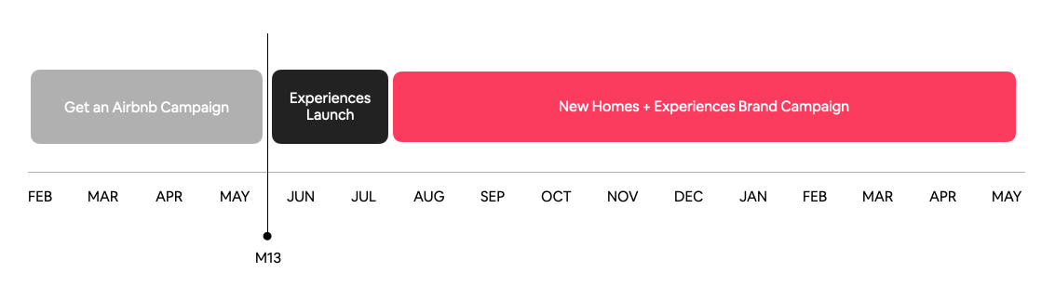
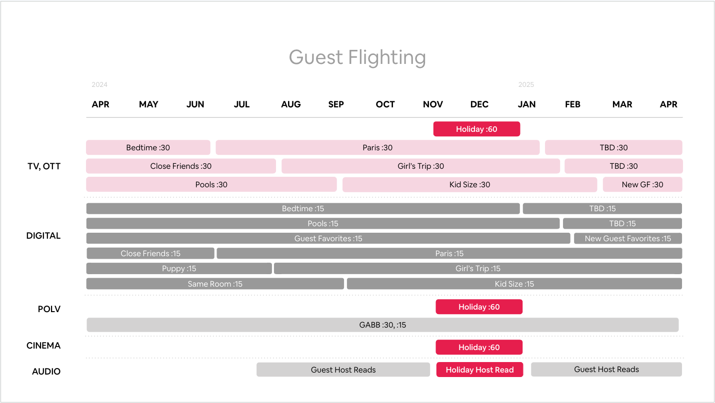

Approach: This is not an easy sell. In order to change behavior, we will need to consistently reinforce reasons to choose us with creative + media designed to breakthrough at every stage of the consumer journey

KPIS: Increase consideration, improve program ROI, drive more FTBs. Additional details to come as we land on M13 and Social strategy

Media principles:
- Deposition hotels: own outsized SOV relative to our competitors in select places where our audiences are
- Win peak booking: heavy up investment leading into and during these periods
- Convincing takes time and repetition: dial up frequency, without becoming VRBO
- For Flighting, we will have a meaningful launch moment in May. We should plan to go bigger in Q2 than this year to support this launch

Markets:
- Existing: US, CA, UK, FR, AU, DE, ES, IT, BR, MX, KR, NL, BE, CH, AR, CO, CL, PE, JP, CN
- There will be no new markets in 2025

2025 Country-level Budget Guidance:
- Global Guest Media budget will decrease -3% Y/Y to $542M, down from $557M. Attached is the tops-down budget guidance by country. However, please flex investment within the ranges below, as we want your perspective on where we may be over or under invested.
- Significant increase [+10% - 25%]: MX, CN
- Modest Increase [+1% - 9%]: BR, EU Exp
- Modest cut [-1% - 10%]: US, CA, FR, GB, AU, DE
- Significant cut [-20% - 40%]: ES, IT, KR
- Newly launched: JP [$27M], ROLA [$12M]

2025 Channel Guidance:
- Focusing facts:
  - Overall business outlook has softened, we are increase our investment mix in conversion driving channels invest more in conversion driving
  - Since 2022, ATL spend has grown considerably while our BTL has remained flat at ~$100M. Our BTL guardrail since 2023 has remained 18%
  - We’re trying to drive product breakthrough and consumer adoption of Experiences in the May launch.
- A greater share of our investment will aim to capture demand and convert to bookings. Our revised BTL recommendation is between 25-30% across markets
- Utilize our 2024 internal MMM results and our platform digital performance to inform BTL mix and channels
- Experiences will be an inherently more social product, and we will make a meaningful investment in Social ATL. Our guidance on Social ATL is to spend at peak 2023 levels, while providing a scenario for social spending that increases at a multiplier of peak 2023 levels to support highly localized amplification of experiences, in addition to Guest Favorites.

The Ask: Based on the above assumptions, lay out for each of our markets:
- How you would recommend deploying that budget by market, channel mix, and budget pacing with clear callouts on what’s different than 2024 and why
- What the above translates into from a R/F lens
- Any notable gaps in the plan, considering things like competitive pressure, seasonality, past performance, etc. (e.g. where would we put our next dollar?)
- What would we cut first if budgets were to decline vs. guidance?
- How do we push the envelope within channels - taking existing learnings and translating them into measurable, iterative improvements?

Initial inputs to inform recommendation:
- 2023 Seasonal search + booking trends to help inform flighting + budget pacing
- Q1 ‘24 MMM to inform necessary shifts in channel mix
- Country specific marketing priorities (regional marketing guidance)
- Inclusion of new channels (Audio, notably)
- Channel consumption data by audience to inform channel mix [Essence]
- Competitor strategy, spend and pacing to help inform overall approach and where we can own SOV [Essence]

Inputs yet to come:
- Post-May, Experiences & Services guidance
- Additional clarity on Social ATL strategy beyond investment strategy captured above

Timing:
- Competitive Analysis delivered for each region/market- by 8/28
- Airbnb to deliver formal brief - 8/28
- Essence to conduct Bottoms up Exercise - 8/29 to 9/30
- Put together global principle/approach
- Regional Teams to run the bottoms up exercise
- Regional x Central to review and align on recommendations for Guest (20 markets)
- Essence to present to Airbnb Central High Level Global Bottoms up Recommendation in G-Sheet - 10/1

